To load multiple files from gen2 to blob using parameter
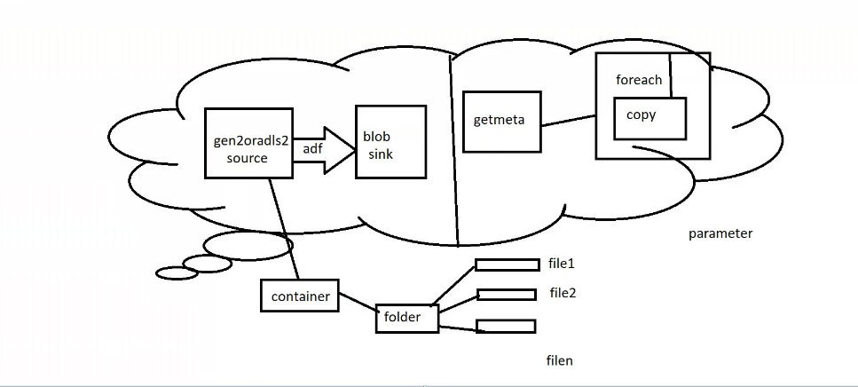
Source side: upload the files
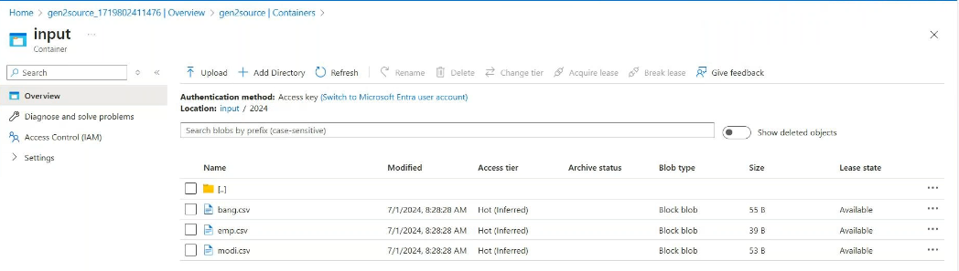
Sinkside:
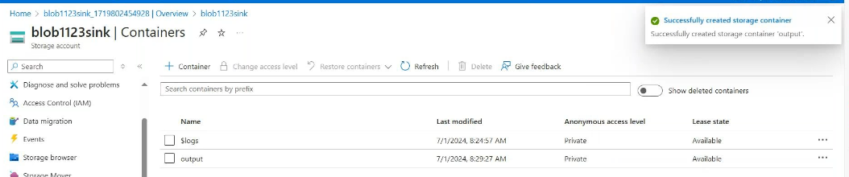
Create linked services sourceside:
In this url : -->go to gen2endpoints -->copy the end point change the instead of blob write dfs
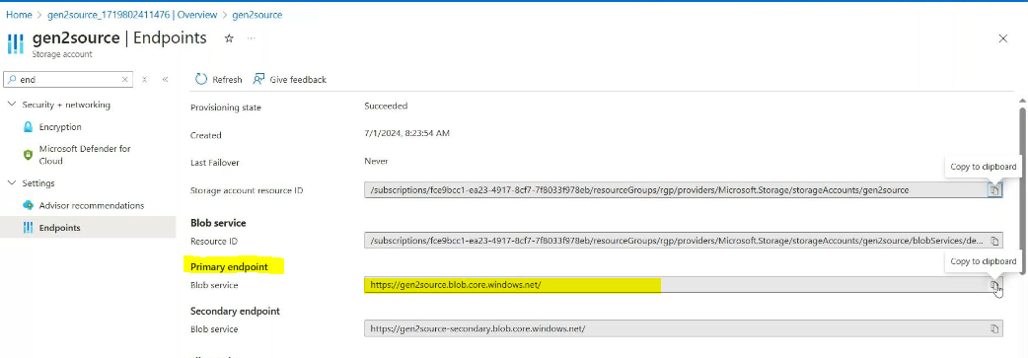
In storage account key: go togen2-->access key
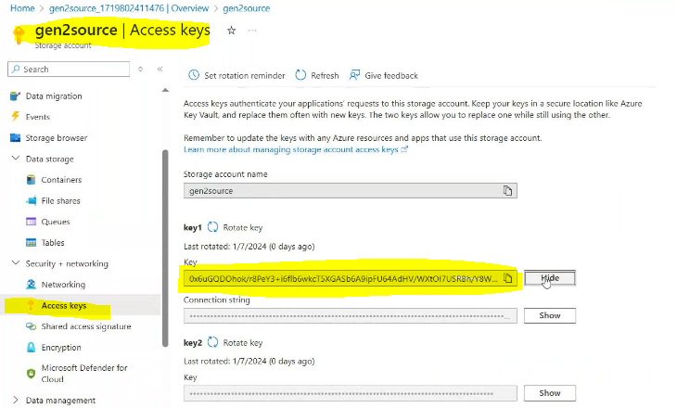

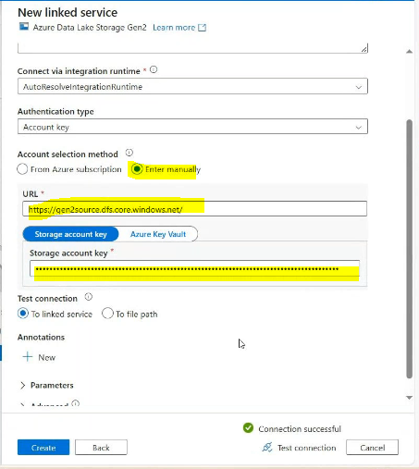

Create linked services sink side:
In storage account : provide the name of blob storage name
Storage account key: provide the Access key of blob storage(like above)
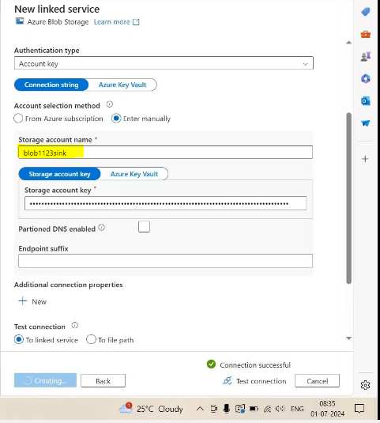

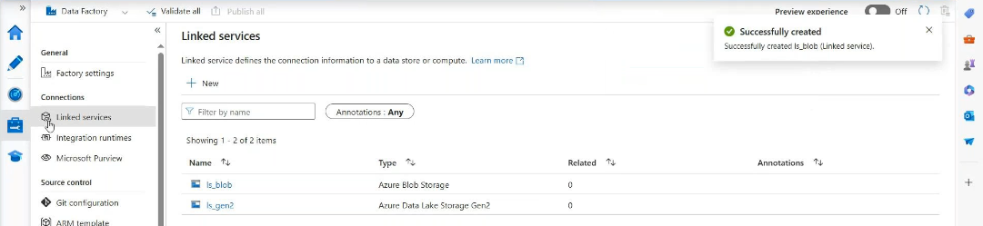

Create source side dataset:
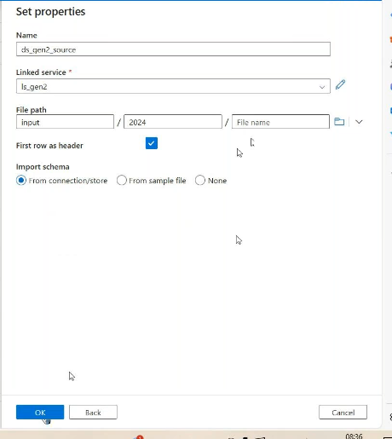
Create sink side dataset:

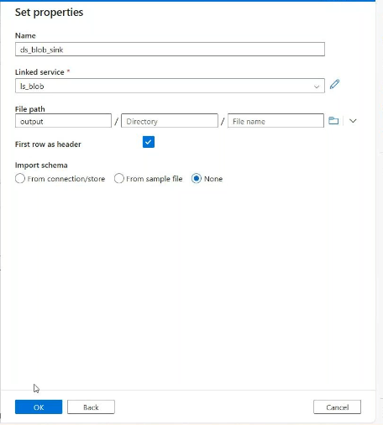
Create a pipeline -drag get metadata activity for that we need to create 1 data set
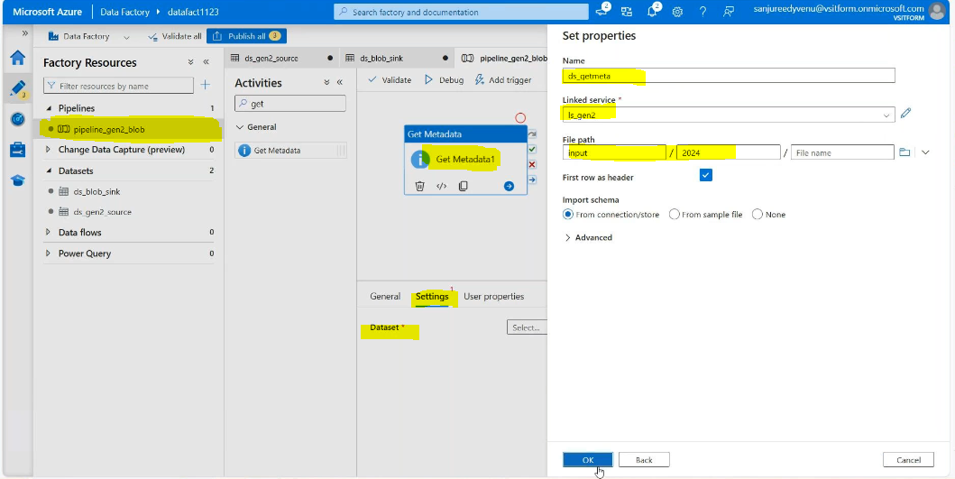

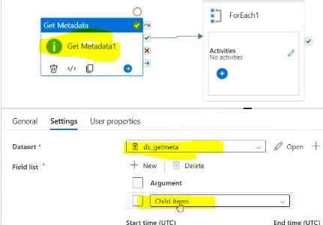
Then validatedebugsecusseded it will getting the information of files
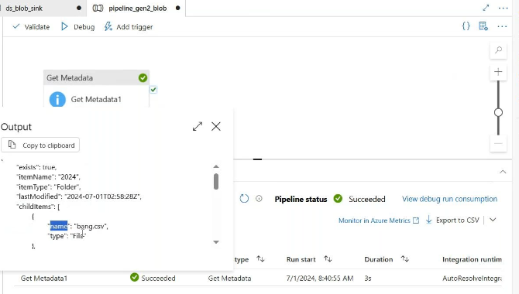
Then call for each activityestablished connection b./w them
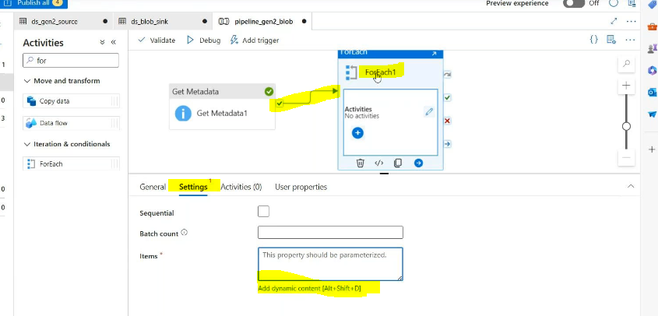
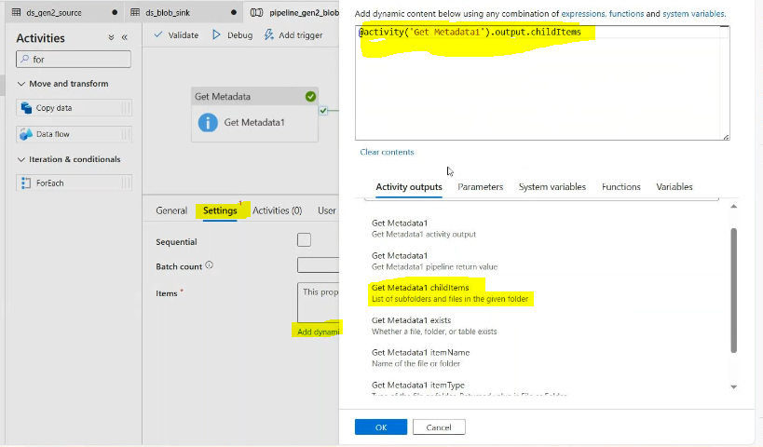
In side for each call copy data activity
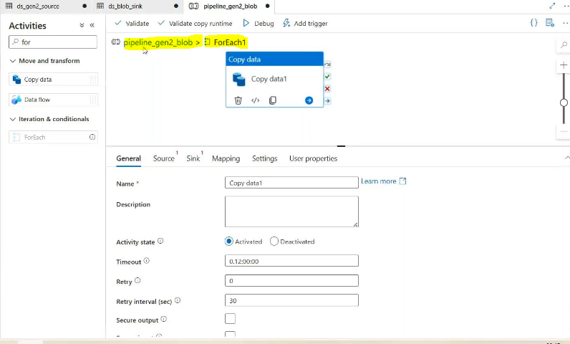
Go to data set what we are create at first then add parameter
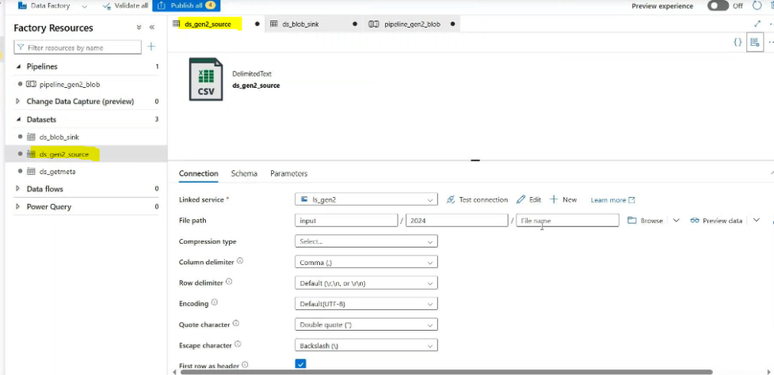
Create a parameter source side:

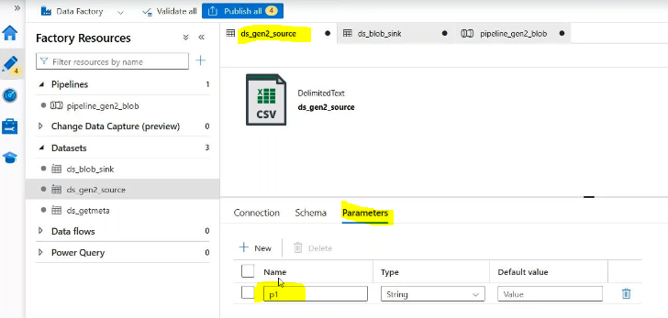
Connection add dynamic value in files level
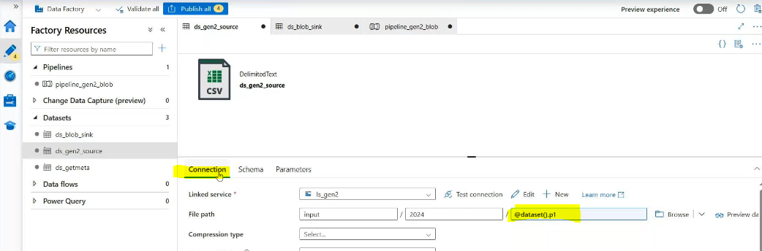
Create a parameter sink side:
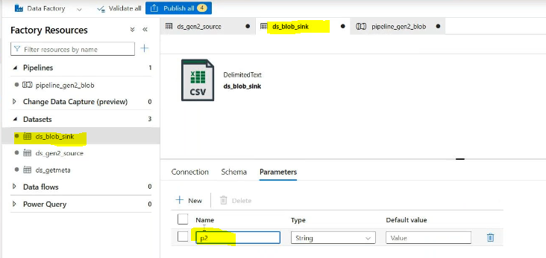
Connections:
Add folder name &in file level add dynamic value
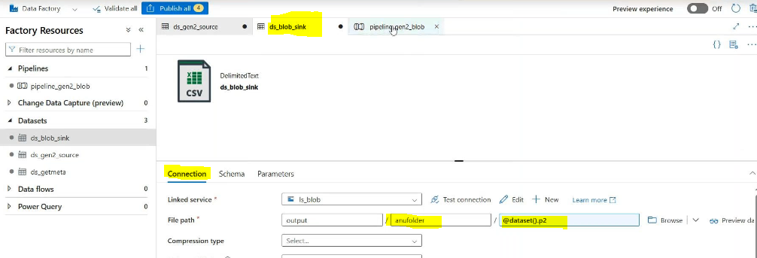

In pipe line level: in foreachcopy data activity source side adddynamic value->select foreach add .name at the end

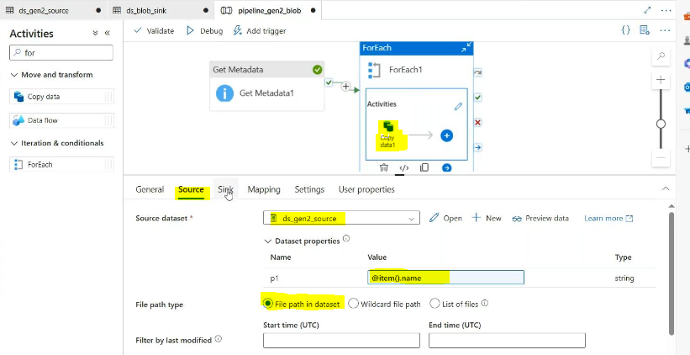
In pipeline level Sink side:
In pipe line level: in foreachcopy data activity sink side adddynamic value->select foreach add .name at the end

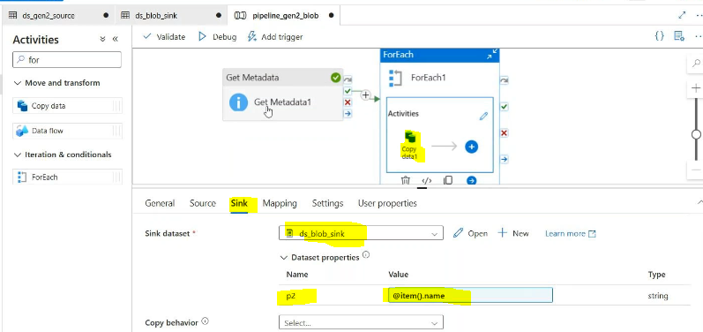

Validate &debug
